TASK – 1

Goal
Create an automation script that performs file operations, renaming, sorting, or cleaning tasks.
Requirements
Use OS module & exception handling
Generate logs for operations
Add user input support
Deliverables
GitHub source code
Sample input/output

"""
File Organizer & Cleaner Automation Script
Requirements: OS module, Exception Handling, Logging, User Input
"""

import os
import shutil
import logging
from datetime import datetime

# Setup logging configuration
logging.basicConfig(
level=logging.INFO,
format="%(asctime)s [%(levelname)s] %(message)s",
handlers=[
logging.FileHandler("file_operations.log"),
logging.StreamHandler() # Echoes logs to the terminal
]
)

# Extension mapping for sorting
TRACKED_EXTENSIONS = {
'Images': ['.jpg', '.jpeg', '.png', '.gif', '.bmp', '.svg'],
'Documents': ['.pdf', '.docx', '.doc', '.txt', '.xlsx', '.pptx', '.csv'],
'Archives': ['.zip', '.tar', '.gz', '.rar', '.7z'],
'Audio_Video': ['.mp3', '.mp4', '.mkv', '.wav', '.mov'],
'Scripts': ['.py', '.sh', '.js', '.html', '.css']
}

def setup_directory(path):
"""Validates the target directory."""
if not os.path.exists(path):
raise FileNotFoundError (f"The directory '{path}' does not exist.")
if not os.path.isdir(path):
raise NotADirectoryError(f"The path '{path}' is not a valid directory.")
return os.path.abspath(path)

def organize_files(target_dir, rename_prefix=None):
"""Sorts and optionally renames files in the target directory."""
print(f"\n🚀 Starting automation in: {target_dir}\n" + "="*50)
logging.info(f"Automation sequence started in directory: {target_dir}")

try:
files = [f for f in os.listdir(target_dir) if os.path.isfile(os.path.join(target_dir, f))]

if not files:
logging.info("No files found to process.")
print("📁 No files found to organize.")
return

success_count = 0
fail_count = 0

for file_name in files:
# Skip the log file itself if it's in the same directory
if file_name == "file_operations.log":
continue

old_path = os.path.join(target_dir, file_name)
name, ext = os.path.splitext(file_name)
ext = ext.lower()

# Determine destination folder category
dest_folder = "Others"
for category, extensions in TRACKED_EXTENSIONS.items():
if ext in extensions:
dest_folder = category
break

dest_dir = os.path.join(target_dir, dest_folder)

try:
# Create category folder if it doesn't exist
if not os.path.exists(dest_dir):
os.makedirs(dest_dir)
logging.info(f"Created category directory: {dest_folder}")

# Handle optional renaming (Prefix_Timestamp_OriginalName)
if rename_prefix:
timestamp = datetime.now().strftime("%Y%m%d")
new_name = f"{rename_prefix}_{timestamp}_{file_name}"
else:
new_name = file_name

new_path = os.path.join(dest_dir, new_name)

# Move (and rename) the file safely
shutil.move(old_path, new_path)
logging.info(f"Successfully moved: '{file_name}' -> '{dest_folder}/{new_name}'")
success_count += 1

except (PermissionError, shutil.Error) as file_err:
logging.error(f"Failed to process file '{file_name}': {file_err}")
fail_count += 1
continue

print(f"\n✅ Operation Complete! Processed: {success_count} files. Failed: {fail_count} files.")
logging.info(f"Sequence finished. Success: {success_count}, Failures: {fail_count}")

except Exception as e:
logging.critical(f"Critical error during automation: {e}")
print(f"❌ A critical error occurred: {e}")

if __name__ == "__main__":
print("🤖 Welcome to the File Automation Assistant 🤖")

# User Input Support
while True:
user_path = input("Enter the absolute path of the directory to organize: ").strip()
try:
target_directory = setup_directory(user_path)
break
except (FileNotFoundError, NotADirectoryError) as err:
print(f"⚠️ Input Error: {err}. Please try again.\n")

want_rename = input("Do you want to add a standard prefix to all files? (y/n): ").strip().lower()
prefix = None
if want_rename == 'y':
prefix = input("Enter the file prefix (e.g., 'Archive', 'ProjectX'): ").strip()

# Trigger automation
organize_files(target_directory, rename_prefix=prefix)

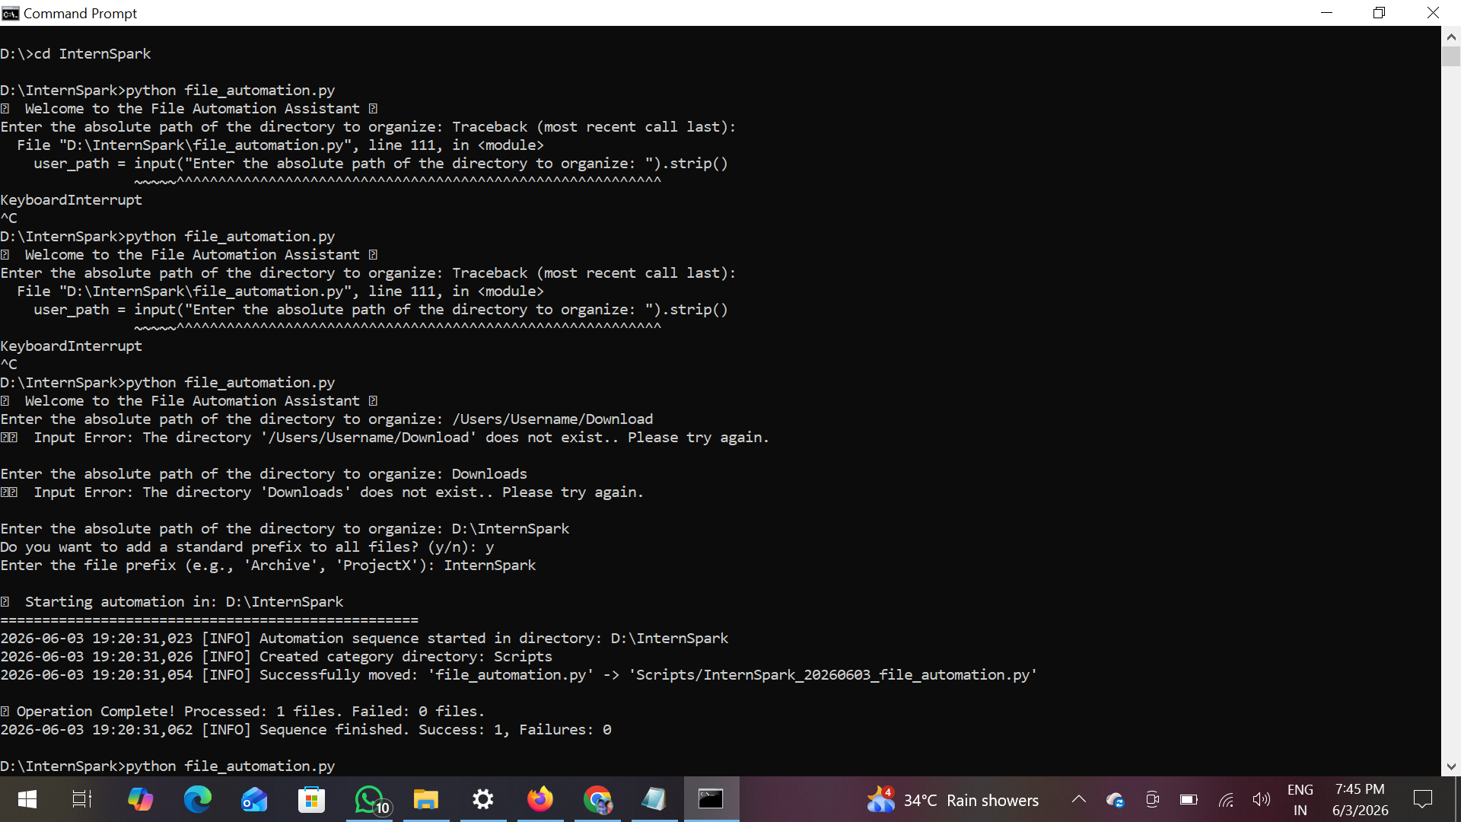

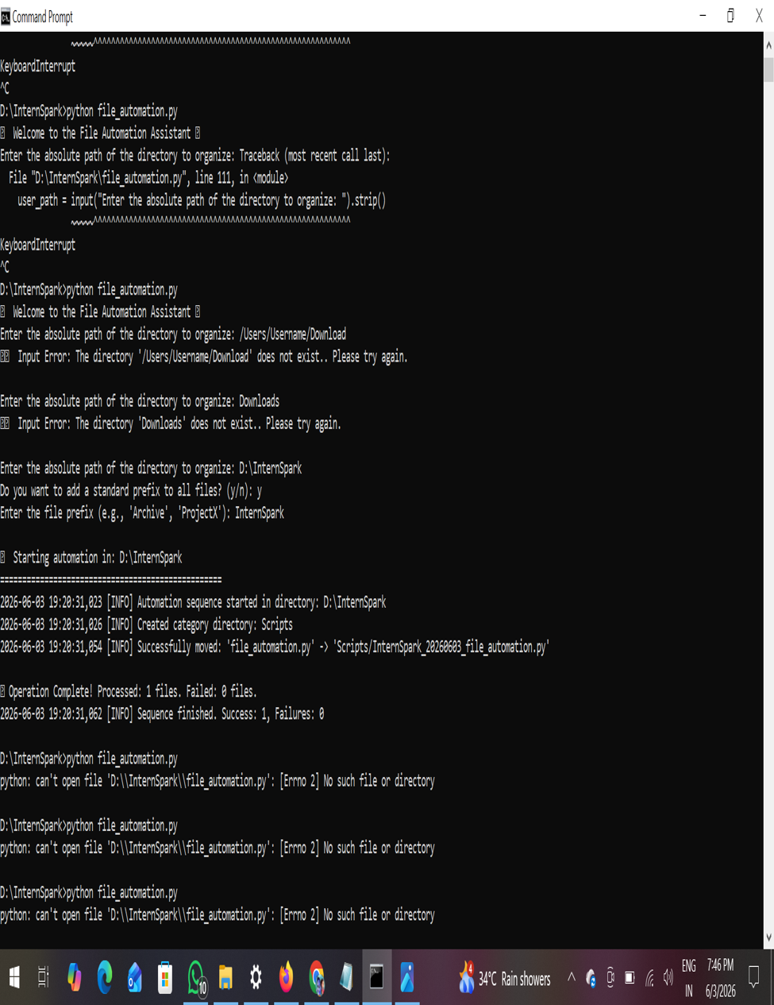

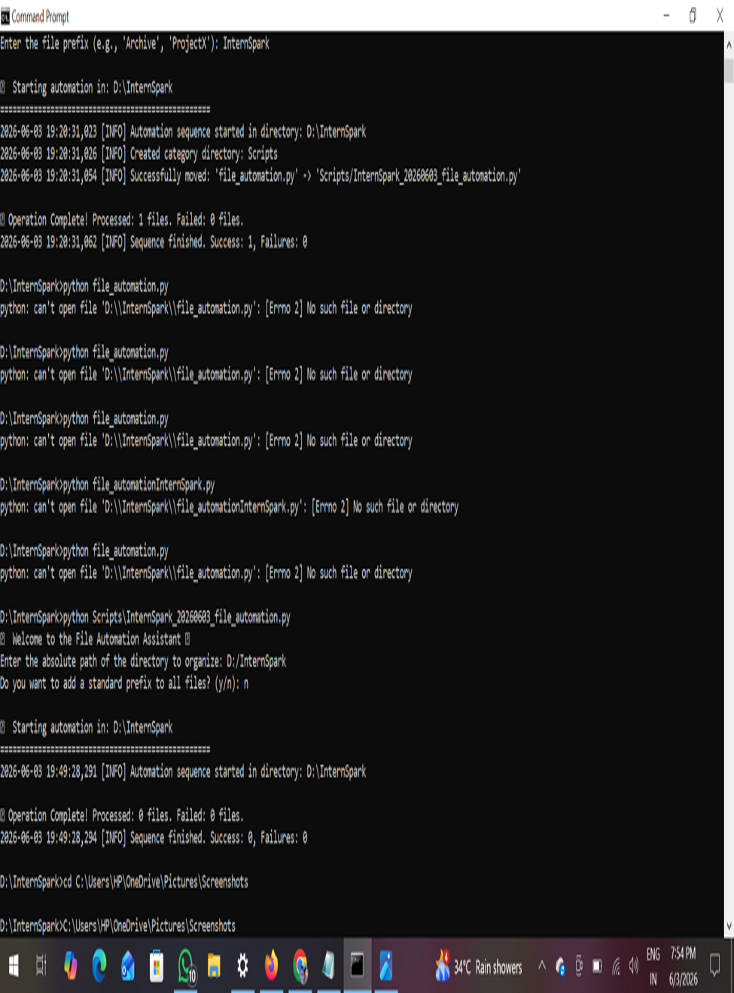

GITHUB REPOSITORY LINK….
https://github.com/DanamPujitha19/InternSpark

GITHUB Task – 1 link…
https://github.com/DanamPujitha19/InternSpark/blob/main/Task%20-%201.docx

